

**Veterans Health Administration (VHA)**

**Prescription Drug Monitoring Program**

**Quality Improvement Study**

**VHA Office of Health Informatics (OHI)**

**Clinical Informatics and Data Management Office (CIDMO)**

**Knowledge Based Systems (KBS)**

**September 2019**

Prepared By:

**Scott D. Wood, PhD, Health System Specialist,** [scott.wood2@va.gov](mailto:scott.wood2@va.gov)

**Steven H. Brown MS MD, Director KBS**

Contents

Executive Summary 3

Acknowledgements 3

Background 3

Baseline PDMP Analysis 3

Method 3

Participants 3

Procedure 3

Hierarchical Task Analysis 4

Task Description 4

As-Is Work Process 6

As-Is Task Timing 8

Clinician Survey 8

Intervention Design 9

Workflow 9

To-Be Task Timing 10

Task Timing Comparison 11

Scenario Analysis and Anticipated Results 12

Evaluation Plan 13

Evaluation Steps 14

Discussion & Recommendations 14

Appendix A Prescriber Questionnaire 16

Appendix B Computer System Usability Questionnaire (CSUQ) 17

# Executive Summary

This report describes the results of a mixed-method study to evaluate a process improvement intervention for monitoring prescription drug use. The purpose of the intervention was to improve efficiency of required documentation related to the prescription of controlled substances. Findings strongly suggest that batch processing of state controlled substance database lookups and charting can significantly reduce administrative burden on providers. Recommendations include expanding use to a clinic-wide pilot to confirm results and consideration for regional or national adoption

# Acknowledgements

# Background

Within the overall medical goal of providing patient care are the subgoals of avoiding patient harm and prescribing medications, which can sometimes be in conflict. To combat opioid misuse, addiction and death, states have instituted prescription drug monitoring programs to help detect when patients “doctor shop” to obtain more controlled prescription medications than clinically appropriate or receiving potentially dangerous combinations of medications from multiple providers (e.g., benzodiazepines concurrent with opiates)

VA prescribers of controlled substances are required to check state-controlled substance registries and document their findings in the Computerized Patient Record System (CPRS). In VISN 9, Prescription Drug Monitoring Program (PDMP) documentation requirements have recently been increased in frequency (from yearly to quarterly) and scope (now including C-IV in addition to C-II). Prescriber compliance with mandated PDMP checks is less than the targeted level of >90%. In addition, some prescribers find the new documentation requirements to be burdensome.

In order to address perceived documentation burdens we assessed baseline practice, developed an informatics-focused intervention and measured the intervention’s impacts in a test environment.

# Baseline PDMP Analysis

## Method

### Participants

Six primary care physicians (PCPs) from one VA clinic participated in the baseline analysis study. One of these participants was in a supervisory role. Participant demographics were not collected.

### Procedure

A mixed-method approach was taken to assess the current process that prescribers must follow to comply with the Prescription Drug Monitoring Program (PDMP) requirements. Unstructured interview, existing PDMP documentation, and observation of one prescriber were used to collect work-process data and derive typical usage scenarios. Hierarchical Task Analysis (HTA) was used to analyze the work specific to prescribing controlled medications and monitoring patient compliance. HTA is a human factors technique for describing the structure of work by decomposing goal-directed tasks into progressively smaller subtasks (Kirwan & Ainsworth, 1992). Business Process Modeling Notation (BPMN) was used to describe the overall workflow, which includes tasks from multiple PMDP stakeholders.

Individual tasks identified in the HTA were described using NGOMSL (Natural Goals Operators Methods Selection Rules Language; Kieras, 1997), a standard technique for describing human-computer interaction. NGOMSL uses a structured natural language notation to describe work in terms of methods for accomplishing goals (tasks and subtasks) and the steps (actions) required to complete the methods. Methods are similar to computer subroutines that are called by a main program or another method using the *Accomplish Goal* operator. Steps are executed in order and always end with a return to the calling method. The *On alert* notation is used to allow for unplanned interruptions, similar to “on error” used in programming, that halts a method in progress and returns after the alert is handled (Wood, 2000). Comments in NGOMSL are preceded by double slashes (“//”).

Task completion times were collected for both the as-is and target tasks through observation of one participant completing PDMP tasks using a simple, high-frequency scenario. A brief written questionnaire was used to assess participant attitudes towards the pre-interventional PDMP process and its impact on patient care.

Collectively, these techniques were used to evaluate how well VA prescribers are able to meet the clinical goal of providing effective, efficient, and safe patient care specific to prescribing controlled substances and the requirements mandated by the PDMP.

## Hierarchical Task Analysis

PDMP adds new administrative steps onto the medical task of prescribing controlled substances in an effort to combat drug abuse, misuse and diversion. PDMP requires prescribers to review state registry data on controlled substance dispensation to patients, and to document that review in the patient record at least quarterly, prior to writing new controlled substance prescriptions.

### Task Description

This section describes the Order Controlled Substance task and how it changes when a PDMP review is required. At the top level of the HTA is a simplified version of a medication ordering task, Order Controlled Substance. If CPRS interrupts the user through an alert, *Handle Order Checking Dialog* (described below) is used to handle the interruption.

**Method for Goal**: *Order Controlled Substance*

// Assume CPRS is running and user is logged in.

**On alert**: Handle Order Checking Dialog

**Step** 1. Create new medication order.

**Step** 2. Add controlled substance to the order.

**Step** 3. Complete and sign the order.

**Step** 4. Return with goal accomplished.

After Step 2, CPRS performs an initial order check, which searches the patient record for a valid PDMP note (e.g. a note titled “” within the past 90 days). When a valid PDMP Note exists in CPRS, Order Controlled Substance can be completed in approximately 54 seconds. However, when a valid PDMP note does not exist CPRS triggers an alert, stopping the user with a modal dialog as shown in Figure 1.

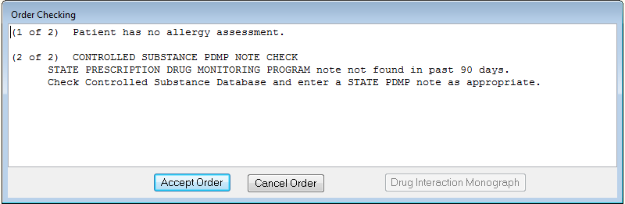

Figure 1. PDMP order check dialog.

At this point, the user must suspend the original Order task and interact with the Order Checking dialog to continue with the order. This is represented in the following subtask:

**Method for Goal**: *Handle Order Checking Dialog*

**Step** 1. Read dialog text.

**Step** 2. Accomplish Goal: Review Registry.

**Step** 3. Switch back to CPRS.

**Step** 4. If nothing suspicious, then Accomplish Goal: Add new PDMP note

else Accomplish Goal: Cancel order.

**Step** 5. Press Accept Order button.

**Step** 6. Enter override statement.

**Step** 7. Return with goal accomplished.

In the most typical case, the users will conduct the required review and enter a new PDMP note. To conduct the review, users perform the Review Registry task using a web browser. The Review Registry task is comprised of several steps that result in either “suspicious activity detected” or “no suspicious activity detected” and is represented as follows:

**Method for Goal**: *Review Registry*

**Step** 1. Launch web browser.

**Step** 2. Navigate to state registry URL.

**Step** 3. Login with prescriber credentials.

**Step** 4. Request data for single patient.

**Step** 5. Review single patient data for suspicious activity.

**Step** 6. Return with goal accomplished.

After the review is completed, users must document the review by placing a PDMP Note in the patient record. To create a PDMP Note, users switch back to CPRS and create a note with a specific title, enabling subsequent PDMP order checks to find it.

**Method for Goal**: *Create PDMP Note*

**Step** 1. Create new note.

**Step** 2. Find and assign PDMP note title.

**Step** 3. Enter note text as “no suspicious activity found”.

**Step** 4. Complete and sign note.

**Step** 5. Return with goal accomplished.

However, when users return back to the Order Checking Dialog, they will still need to enter a reason for overriding the order check even though they did what the order check told them to do, as shown in Figure 2. Their only other alternative would be to cancel the order and start over again, which would take longer than typing a short explanation (which is no longer meaningful, medically or otherwise). The most time-consuming aspect of this step is likely thinking of a phrase that is accurate, concise and professional.

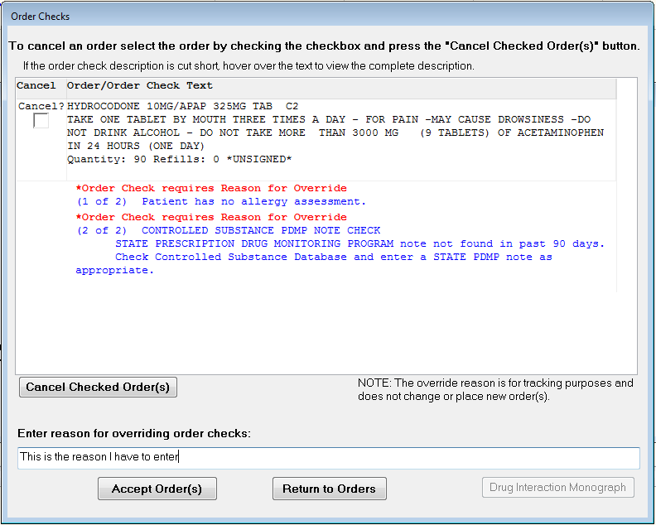

Figure 2. Order Checks dialog with override explanation.

Once an explanation is entered, the user can press Accept Order, which completes the *Handle Order Checking Dialog* task. The user can then resume the original *Order Controlled Substance* task at Step 3 to complete and sign the order.

## As-Is Work Process

The target work process in this analysis is *Controlled Substance Ordering*, which exists within the broader process of *Patient Care*. Figure 3 illustrates a simplified view of the as-is controlled substance ordering process using BPMN. The token moving through the process is the medication order, which is typically initiated by the patient, either via a phone request to a call center or directly during a care encounter with the prescriber. If the patient request is via the call center, a notification is sent to the prescriber via CPRS. After notification or verbal request (assuming the requested drug is medically warranted) the prescriber begins the *Create Medication Order* task within CPRS. When the requested controlled substance is added to the order, CPRS initiates its first clinical reminder order check (shown as *CROC*). One purpose of the order check is to verify existence in the patient’s record of a recent “PDMP Note,” which documents that a provider has reviewed state-provided information about the patient and that nothing illegal or otherwise suspicious regarding controlled substances has been found. If a PDMP note dated within the last 90 days is not found, CPRS will interrupt the *Create Medication Order* task to prompt the prescriber to first review the state registry. This new subtask consists of several steps, including logging into the state registry (shown as *Login to TNCSMD*), entering patient information, and reviewing the state-compiled results. If no suspicious data is found, the prescriber creates a PDMP note attesting to the review, which completes the Review Registry subtask. The prescriber can then complete the Override Order Check subtask by entering a justification statement (such as “Just checked”) and can complete the Controlled Substance Ordering task by signing the prescription order.

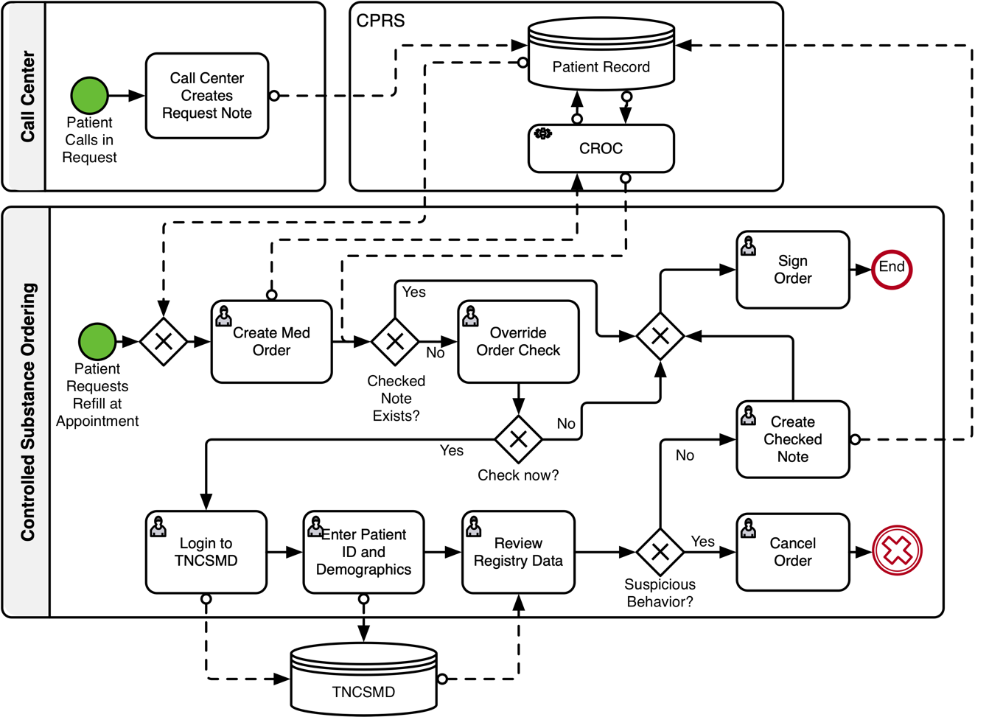

Figure 3. As-is work process for prescribing a controlled substance.

Although there are many variations of the basic workflow, several points are clear:

1. Without PDMP, the only essential actions in Controlled Substance Ordering would be Create Medication Order and Sign Order.
2. The tasks required by PDMP add substantial steps, time and effort to the basic Controlled Substance Ordering process, as evidenced by the multiple decisions (4) and actions (6) in addition to the essential actions.
3. Tasks that interrupt other tasks are disruptive to cognition and decision-making, which makes task performance less efficient and may lead to adverse events.
4. Patient encounters are zero-sum regarding time, so any non-value-added tasks performed during a patient encounter reduces time that can be spent on other aspects of patient care. Shifting task performance outside of the patient encounter can improve patient care.
5. The cumulative time added for prescribers may be substantial, depending on the number of patients in their panel who require controlled substances for treatment. Shifting responsibility to non-prescribers for administrative tasks can reduce unnecessary burden on prescribers.

## As-Is Task Timing

Task execution time was collected for the described tasks to estimate how changes to the work process by either modifying the work process or shifting work to other roles can improve prescriber workload and provide more time with patients. As such, the data collection goal was to develop standard timing measures for discrete subtasks and actions that will allow meaningful comparisons between As-Is and To-Be process designs. To allow comparisons for reviewing multiple patients at a time, timing data was collected separately for tasks specific to a review session, irrespective of how many patients are checked (overhead tasks, such as system login) and those tasks that must be repeated for each patient reviewed (per patient time). Task execution times were collected through observation of one expert prescriber performing multiple runs through a simple, 1-patient, 1-medication prescribing scenario. It is important to note that this type of analysis would not be valid for drawing conclusions based on absolute task times without additional data from multiple participants. Table 1 summarizes the collected task times for the As-Is tasks.

Table 1. Task times for As-Is tasks.

|  |  |  |
| --- | --- | --- |
| **Subtask** | **Time (mm:ss)** | **Task type** |
| Create prescription | 00:15 | Per patient |
| Order check dialog | 00:01 | Per patient |
| Launch TNCSMD and Login | 00:48 | Overhead |
| Find patient | 00:41 | Per patient |
| Review registry data | 00:19 | Per patient |
| Add new PDMP note | 00:37 | Per patient |
| Complete override and sign order | 00:34 | Per patient |
| **Total task time** | **03:15** | **Per patient** |

For comparison, the time to complete *Order Controlled Substance* without interruption was 54 seconds.

## Clinician Survey

A small sample of primary care prescribers (n=6) was surveyed to better understand user perceptions of the As-Is system, establish some baseline metrics, and identify any themes regarding clinical usage of PDMP. Table 2 summarizes perceived value on a 5-point Likert scale (1=most negative, 5=most positive):

Table 2. User perceptions of PDMP value and As-Is process.

|  |  |  |
| --- | --- | --- |
| **Topic** | **Mean Value (n=6)** | **Interpretation** |
| Overall experience | 3.0 | Neutral |
| PDMP Effectiveness | 4.5 | Positive |
| Impact on Care | 4.3 | Positive |
| Process Efficiency | 2.0 | Negative |

In general, prescribers find value in the PDMP program and believe its impact on patient care is positive, but feel the As-Is process is inefficient.

Other themes that emerged from the survey include:

1. PDMP process is useful, but not useable.
2. Awareness of reported clinician compliance rates is uneven.
3. Surrogate processes, such as when one clinician fills in for another or when clinicians-in-training are involved, non-adherence to the required process may contribute to less-than-target compliance rates.
4. Creating a PDMP-check note increases prescribing complexity, resulting in prescribing errors.
5. Only 1/3 of respondents check for a PDMP review note prior to writing a prescription.
6. Almost half of respondents believe PDMP is not useful for non-opiate drugs
7. Almost half of respondents believe the PDMP process should be made more efficient
8. Almost all respondents list process-related pain points
9. Almost all respondents believe PDMP contributes to patient safety
10. Half of respondents believe the PDMP process detracts from the patient encounter

# Intervention Design

There are three key objectives of the intervention:

1. Create spreadsheets per prescriber for all patients likely to need a monitored drug prescription in the near future.
2. Allow prescribers to perform PDMP checks as a batch for all patients in a spreadsheet
3. Allow prescribers to efficiently apply one “group note” to multiple patients as warranted.
4. Shift purely administrative tasks to administrative roles.

The first two objectives were accomplished by utilizing a prepared script in the VA Corporate Data Warehouse that finds all patients for a selected prescriber who are likely to need a prescription for a monitored drug in the upcoming week. The script creates a CSV spreadsheet file containing the demographic information necessary in the required format to perform a TNCSMD batch search. The resulting spreadsheet serves as a “punch list” for the prescriber that enables the more efficient batch PDMP check.

The third objective was met via the use of the VA CPRS “group notes” capability. Group notes was preconfigured for this task with required Text Integration Utilities and encounter data.

The fourth objective will be addressed during clinic wide implementation by assigning administrative staff the job of running the punch-list generation reports and securely e-mailing them to the appropriate prescriber.

If successful, this intervention will provide benefit in four main areas:

1. PDMP checks will not take valuable face-time away from patient visits.
2. The administrative burden placed on prescribers by the PDMP program will be reduced.
3. The overall cost for complying with PDMP requirements will be reduced.
4. Compliance with PDMP requirements will be increased

An additional benefit for patients will be that prescribers will have additional time prior to patient visit to explore treatment alternatives should the PDMP check for a patient indicate contraindicative behavior.

## Workflow

The overall workflow illustrated in Figure 3 does not change – there will always be instances where the need for a PDMP check cannot be predicted. Instead, the intervention seeks to modify the conditions under which the medication order is processed to reduce instances where a PDMP Note does not exist.

The intervention creates two additional workflows to improve the monitored drug ordering conditions. Figure 4 illustrates the first workflow, which generates a “Punch List” (i.e., a spreadsheet) of patients for a prescriber that can be uploaded to the PDMP site. The workflow is initiated by the user on a weekly basis, as determined by the clinic or prescriber. The user accesses the report in the CDW reporting area via web browser, enters reporting parameters per prescriber, and runs the report to generate the punch list of patients who need a PDMP check. The user then downloads the punch list as a structured text file (i.e. a spreadsheet stored in comma-separated-value format). The workflow ends when the user sends this file to the prescriber. Because there are no medical or medicolegal decisions in this workflow, it can be delegated to an administrative or non-clinical role.

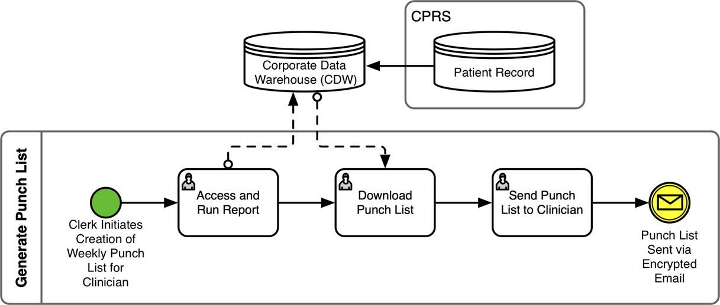

Figure 4. Proposed administrative workflow for generating a list of patients likely to need a PDMP-monitored drug but whose history has not been checked within the required timeframe.

The second workflow, shown in Figure 5, illustrates the batched PDMP checks that can be performed by a prescriber utilizing the punch list (spreadsheet) generated previously. It begins with receipt of the punch list via secure email. The prescriber then logs into the PDMP registry site, uploads the spreadsheet, and reviews the results for each of the patients listed. If no suspicious activity is found (the most common situation), a group note is created which is then automatically placed in each of the patient’s medical record. If suspicious activity is detected for a patient, that patient can be removed from the group note and handled separated according to protocol.

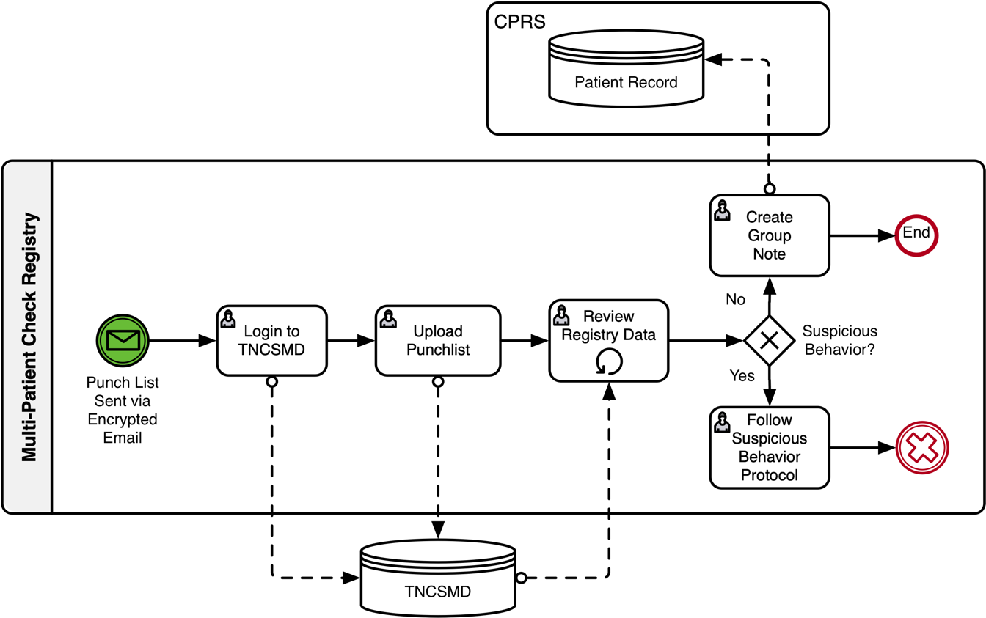

Figure 5. Multi-Patient PDMP-check workflow.

## To-Be Task Timing

Times were observed for tasks within the administrative workflow to compare against the extant, As-Is workflow, and are shown in Table 3. For each prescriber with PDMP patients, the user will generate a punch list for the following week. It is anticipated that punch lists for multiple prescribers (e.g. for an entire clinic) will be generated in the same session. Because these tasks can be completed by administrative users, the cost can be lower than if complete by clinicians. These times will be utilized in a subsequent analysis section of this report. This administrative workflow may be further optimized by generating all punch lists from a single clinic-wide predictive report, if we can ensure that such optimization will not have a negative effect on individual clinicians.

Table 3. Task times for To-Be Generate Punch List workflow.

|  |  |  |
| --- | --- | --- |
| **Subtask** | **Time (mm:ss)** | **Task type** |
| Launch and run report | 00:49 | Per prescriber |
| Download report spreadsheet | 00:18 | Per prescriber |
| Send punch list to prescriber | 00:30 (estimated) | Per prescriber |
| Total task time | **01:37** | **Per prescriber** |

Once a punch list is received by a prescriber, the prescriber can perform a batched, multi-patient PDMP check for all patients in the punch list. This is followed by the primary task of entering a prescription without interruption. Table 4 lists observed task times for activities within the Multi-Patient Check Registry workflow. These times are segmented into per-batch and per-patient times. Per-batch time is considered overhead execution time for performing the batch task irrespective of the number of patients within that batch. Per-patient time is added to the per-batch time for each patient within a single punch list. Thus, the more patients within a punch list, the lower the overhead costs per patient per PDMP check. These values will be utilized in a subsequent scenario analysis.

Table 4. Task times for To-Be multi-patient (batch) PDMP check tasks with prescription ordering.

|  |  |  |
| --- | --- | --- |
| **Subtask** | **Time (mm:ss)** | **Task type** |
| Receive punch list from clerk | 00:30 (estimated) | Per batch check |
| Login to TNCSMD | 00:48 | Per batch check |
| Upload report spreadsheet | 00:50 | Per batch check |
| Create group note | 00:34 | Per batch check |
| Enter group note text and sign | 00:39 | Per batch check |
| Total batch overhead time | **03:21** | **Per batch, not including per patient time** |
|  |  |  |
| Review registry data | 00:19 | Per patient in batch |
| Enter patient identifier in group note | 00:08 | Per patient in batch |
| Enter prescription without interruption | 00:54 | Per patient |
| Total task time per patient | **01:21** | **Per patient in batch, to be added to overhead time** |

## Task Timing Comparison

We assume for the As-Is workflow that patient PDMP checks will be performed only as needed, when alerted by the order check process. With this assumption, each step in the PDMP task must be performed for each patient, including writing the initial prescription, so the overhead cost of logging into TNCSMD cannot be spread across multiple patients. As shown in Table 1, we estimate these steps to take approximately 03:15 (mm:ss) per patient. The task time for two patients would be twice this, 06:30 (mm:ss).

In contrast, we assume the To-Be workflow to be performed prior to the patient encounter such that multiple patients can be checked in a single batch. With this assumption, To-Be task time includes the overhead time for performing a batch, combined with a per patient time for each patient included in the batch. Per-patient time includes reviewing registry data, entering patient identifier into the group note, and writing a prescription without interruption. As shown in Table 4, we estimate the task time for one patient to be 03:03 (mm:ss) in overhead plus 01:20 (mm:ss) for the single patient, for a total task time of 04:23 (mm:ss), more than a minute longer than the As-Is workflow for a single patient. For two patients, however, the task time would include 03:03 (mm:ss) in overhead plus 02:40 (mm:ss) for the two patients (at 1 minute, 20 seconds each) for a total task time of 05:44 (mm:ss), 45 seconds less than the As-Is workflow. Time savings increase linearly with increasing batch sizes. Figure 6 shows prescriber task times for As-Is and To-Be workflows as the number of patients per batch increases.

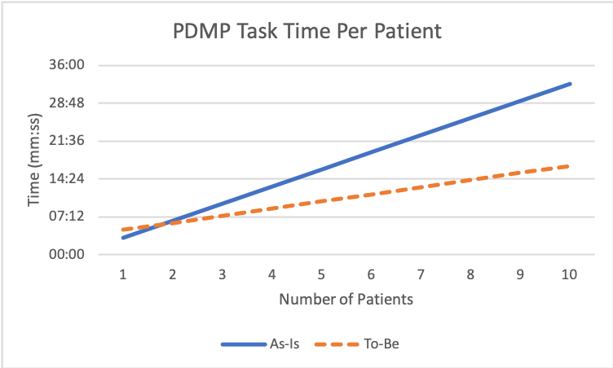

Break even after 1 patient

Figure 6. Comparison of As-Is and To-Be prescriber task time for multiple patients.

## Scenario Analysis and Anticipated Results

A simple scenario will be used to compare task times for the As-Is and To-Be workflows. In this scenario we assume that two clinics each have five providers with five PDMP patients each. Clinic A prescribers use the As-Is workflow exclusively, performing PDMP checks only when interrupted by the PDMP order check. Clinic B has an administrative clerk to generate punch lists and is able to utilize the To-Be workflow for all 25 patients. Table 5 shows the comparative task times for this scenario.

Table 5. Scenario analysis comparing As-Is with To-Be workflows for 5 prescribers with 3 PDMP patients each. Time given in minutes and seconds (mm:ss).

|  |  |  |  |  |  |  |  |  |  |
| --- | --- | --- | --- | --- | --- | --- | --- | --- | --- |
|  |  | **Clinic A (As-Is)** | | | |  | **Clinic B (To-Be)** | | |
| **Subtask** |  | **# Units** | **Time/Unit** | **Total** |  | | **# Units** | **Time/Unit** | **Total** |
| Individual PDMP Check |  | 25 patients | 03:15 | 81:15 |  | |  |  |  |
| Generate Punch List |  |  |  |  |  | | 5 prescribers | 01:37 | 08:05 |
| Batch PDMP Check Overhead |  |  |  |  |  | | 5 prescribers | 03:21 | 16:45 |
| Batch PDMP per patient |  |  |  |  |  | | 25 patients | 01:21 | 33:45 |
| Total Scenario Time |  |  |  | **81:15** |  | |  |  | **58:35** |

This scenario shows a total time saving of 22:40 (mm:ss), approximately 28% less than the As-Is time. Significantly, this total time savings represents a savings for prescribers of 30:35 (mm:ss) or ~38% given a batch size of 5 patients. To estimate the cost comparison, we will assume some rough costs per role as shown in Table 6 (Note: Average salary per year is used as a proxy for cost. True cost is much higher).

Table 6. Per unit costs by role.

|  |  |  |  |  |
| --- | --- | --- | --- | --- |
|  |  | **Cost** |  |  |
| **Role** | **Per Year** | **Per Hour** | **Per Minute** | **Per Second** |
| Primary Care Physician | $178000 | $85.58 | $1.43 | 0.023771368 |
| Administrative Clerk | $50000 | $24.04 | $0.40 | 0.00667735 |

Table 7 factors role cost into the comparison, showing a 35% savings for the To-Be condition in the scenario.

Table 7. As-Is/To-Be cost comparison for 5-prescriber, 5-patient scenario.

|  |  |  |  |  |
| --- | --- | --- | --- | --- |
| **Measure** | **Clinic A (As-Is)** | **Clinic B (To-Be)** | **Amt Saved** | **% Saved** |
| Time (mm:ss) | 81:15 | 58:35 | 22:40 | 28% |
| Cost | $115.89 | $75.27 | $40.62 | 35% |

Note that all of the time spent performing batch PDMP checks is outside of patient visit time.

## Analysis Discussion & Recommendations

This study found that the batch-based intervention provides substantial time and cost efficiencies compared to the existing one-off ad hoc process. Prescriber time-savings of 38% and overall cost savings of 35% were calculated for a batch size of 5 patients. Savings would increase with larger batch sizes. Unmeasured, but reasonably anticipated benefits of the intervention include enhanced provider satisfaction, increased time for interpersonal interaction during visits and diminished cognitive load.

We recommend that this intervention be piloted in a live clinical setting to fine-tune the intervention, confirm our findings regarding efficiencies and to document potential changes in prescriber compliance and perceptions regarding CSMD documentation requirements.

# Evaluation Plan

Our primary intervention goal is to ensure high compliance rates by prescribers. Thus, the obvious strategy would be to evaluate change in physician compliance rates directly. However, compliance rates are generally over 95% already, so a lot of data would be required to demonstrate a meaningful change.

Two of the identified success goals (see Intervention Design) are to reduce physician time requirements for achieving high compliance rates, and perhaps more important, to reduce unnecessary interruptions during patient encounters. Measuring time spent to comply directly would take a lot of time, effort, and resources. However, a key indicator of wasted time during encounters is the PDMP alert (see Figure 1). Each time the PDMP alert is fired during an encounter it indicates at least a few seconds of care disruption and potentially several minutes, that is, if the prescriber actually checks the registry prior to writing the prescription (as we modeled). Prescriptions for patients not already in the registry are indicated by a Last PDMP of “Not Documented” – these are likely not preventable. If PDMP alerts can be substantially reduced for patients already registered in TNCSMD (and a corresponding PDMP note in CPRS), it will represent a positive improvement in at least three of the four success criteria.

The Charlotte Ave clinic wrote 414 PDMP prescriptions in August, with 407 in compliance (98%). Over 70% of those prescriptions (302) were written by 2 prescribers. The Override Reasons report shows 148 prescriptions (36%) that triggered overrides in August, which is fairly consistent over the last three months. 11 of these prescriptions (7% of the overrides) represent new prescriptions that are not predictable. 24 of the overrides (16%) did not have a corresponding PDMP note written on the same day, representing missed opportunities. Based on this data and the analysis presented above, it will be valuable to assess the proposed intervention impact using the Charlotte Ave clinic as a pilot site.

If we can demonstrate a significant reduction in the number of unnecessary overrides (say, by half), one or two months of data should be sufficient to indicate any performance trends. We would want to include at least the two main prescribers in the intervention assessment, but assessing the whole clinic would give a more accurate picture, account for individual prescriber schedule variation (like vacation or work travel during the evaluation period) and allow for a shorter evaluation period (1 month vs 6). This would give us enough data to determine whether a broader evaluation (beyond Charlotte Ave) is warranted.

To implement the assessment, we will need to make sure everyone involved is trained on using the weekly predicted PDMP-need reports. Ideally, the date of report delivery to the prescriber would be tailored to each prescriber’s schedule so that their report is delivered just-in-time for whatever admin time-slot they would have available each week (to catch any last-minute appointments or changes). Nominally, a Friday morning delivery of the predictive report is fine for prescribers who have available time on Friday to check registry prior to Monday appointments. However, a fixed delivery schedule may not work well for some prescribers which would pollute the data if they are not able to work the predictive checks into their schedules. Ideally, we would want to ask each prescriber in advance to determine the best day of week to deliver the predictive report. In any case, we will need to track whether prescribers are able to use the predictive report each week (automating this would be ideal). It would also be nice to survey prescribers before and after to assess perceived value of the intervention – this could be done with less than 5 questions, but this is not necessary if the override results are sufficiently compelling. One risk to such non-observed data collection is whether prescribers are performing the tasks the way we think they are (both for individual patients now and batched patient lists during assessment). For example, if prescribers are using an abbreviated PDMP check now, any perceived or actual benefits from the intervention may be reduced. Likewise, if prescribers do not adhere to the nominal task flow during the evaluation period, data quality will suffer. Data from the PDMP Override Reasons report should be indicative for this risk (if overrides are not dramatically reduced, then we know there is unseen performance variation across prescribers). To mitigate this risk, override data can be checked on a weekly basis and we can address task performance variance as needed.

## Evaluation Steps

1. Obtain necessary permissions
2. Determine evaluation start date
3. Train administrative support personnel regarding generating and distributing predictive reports (1 primary, 1 backup)
4. Ensure all clinicians are trained on to-be workflow, are aware of their responsibilities, determine ideal predictive report delivery schedule, and obtain their consent to participate in evaluation
5. Set predictive report schedule
6. Establish POC for participant questions during evaluation period (nominally Wood or Brown)
7. Conduct Computer System Usability Questionnaire (CSUQ) for As-Is PDMP process to participants (SDW note: not powerful enough for less than 15 providers)
8. Pilot test the To-Be process for one week to ensure all participants are able to perform their respective tasks without assistance.
9. Continue running To-Be process for 4 additional weeks. If substantial changes to workflow become necessary, restart 4-week schedule.
10. Review PDMP Order Check reports (specifically, a modified version of the PDMP Override Reasons report) at the end of each week and log results.
11. Administer Computer System Usability Questionnaire (CSUQ) to participants for To-Be PDMP process as evaluated (SDW note: not powerful enough for less than 15 providers)
12. Compile and report on results

Appendix A Prescriber Questionnaire

PDMP Prescriber Interview Date: ____________

*I’m conducting a study of the Prescription Drug Monitoring Program process for prescribers and would like to ask you some questions to better understand the process and context. We will anonymize individual responses.*

1. How would you rate your overall experience with the current PDMP process, where 1 is horrible and 5 is perfect?
2. How would you rate the effectiveness of the PDMP process on a scale from 1 to 5, where 1 is not effective at all and 5 very effective?
3. How would you rate the effect of PDMP on your patient care on a scale from 1 to 5, where 1 is strong negative effect and 5 is strong positive effect?
4. How would you rate the efficiency of the PDMP work process on a scale from 1 to 5, where 1 is not efficient at all and 5 very efficient?
5. Can you describe your overall experience with the PDMP process?
6. Are you aware of your compliance rate? Is it higher or lower than the 90% target?
7. Why do you think you are at this rate?
8. What is your current process when prescribing drugs for which monitoring is required?
9. Do you use any specific strategies to complete the process?
10. Do you think the current process is reasonable? How so?
11. Are there specific pain points associated with the PDMP process?
12. Do you think the PDMP adds value to patient care? How?
13. Does the current process have a positive or negative effect on patient visits?
14. How would you improve the PDMP process?

Appendix B Computer System Usability Questionnaire (CSUQ)

|  |  |  |  |  |  |  |  |  |  |  |  |
| --- | --- | --- | --- | --- | --- | --- | --- | --- | --- | --- | --- |
|  |  |  | **1** | **2** | **3** | **4** | **5** | **6** | **7** |  | **NA** |
| 1. | Overall, I am satisfied with how easy it is to use this system | strongly disagree |  |  |  |  |  |  |  | strongly agree |  |
| 2. | It was simple to use this system | strongly disagree |  |  |  |  |  |  |  | strongly agree |  |
| 3. | I can effectively complete my work using this system | strongly disagree |  |  |  |  |  |  |  | strongly agree |  |
| 4. | I am able to complete my work quickly using this system | strongly disagree |  |  |  |  |  |  |  | strongly agree |  |
| 5. | I am able to efficiently complete my work using this system | strongly disagree |  |  |  |  |  |  |  | strongly agree |  |
| 6. | I feel comfortable using this system | strongly disagree |  |  |  |  |  |  |  | strongly agree |  |
| 7. | It was easy to learn to use this system | strongly disagree |  |  |  |  |  |  |  | strongly agree |  |
| 8. | I believe I became productive quickly using this system | strongly disagree |  |  |  |  |  |  |  | strongly agree |  |
| 9. | The system gives error messages that clearly tell me how to fix problems | strongly disagree |  |  |  |  |  |  |  | strongly agree |  |
| 10. | Whenever I make a mistake using the system, I recover easily and quickly | strongly disagree |  |  |  |  |  |  |  | strongly agree |  |
| 11. | The information (such as online help, on-screen messages, and other documentation) provided with this system is clear | strongly disagree |  |  |  |  |  |  |  | strongly agree |  |
| 12. | It is easy to find the information I needed | strongly disagree |  |  |  |  |  |  |  | strongly agree |  |
| 13. | The information provided for the system is easy to understand | strongly disagree |  |  |  |  |  |  |  | strongly agree |  |
| 14. | The information is effective in helping me complete the tasks and scenarios | strongly disagree |  |  |  |  |  |  |  | strongly agree |  |
| 15. | The organization of information on the system screens is clear | strongly disagree |  |  |  |  |  |  |  | strongly agree |  |
| 16. | The interface of this system is pleasant | strongly disagree |  |  |  |  |  |  |  | strongly agree |  |
| 17. | I like using the interface of this system | strongly disagree |  |  |  |  |  |  |  | strongly agree |  |
| 18. | This system has all the functions and capabilities I expect it to have | strongly disagree |  |  |  |  |  |  |  | strongly agree |  |
| 19. | Overall, I am satisfied with this system | strongly disagree |  |  |  |  |  |  |  | strongly agree |  |
|  |  |  | **1** | **2** | **3** | **4** | **5** | **6** | **7** |  | **NA** |

List the most **negative** aspect(s):

List the most **positive** aspect(s):